 San Francisco Bay University

EE461 Digital Design and HDL

Week#6 "if/case/casex/casez" Conditional Statements

1. Lab Outlines:

- "if" Conditional statements
- Continuous assignment with conditional operator
- "case" conditional statement
- "casex" conditional statements
- "casez" conditional statements

2. Lab Procedures

I. "if" Conditional statements
- if(a == yyyy) : For "== " or "!=" checking
if a has x or z, then (a == yyyy) = x (unknown) or (a != yyyy) = x (unknown).

Example:
module IfTest();
reg [3:0] X;
reg [3:0] Y;
initial begin
X=4'b101x;
Y=4'b101z;
if(X==4'b101z)begin
$display("Statement 1 has been selected!");
end
if(X==Y)begin
$display("Statement 2 has been selected!");
end
if(X!=Y)begin
$display("Statement 3 has been selected!");
end
if(X==X)begin
$display("Statement 4 has been selected!");
end
$display("No one has been selected!");
end
endmodule
Ans: ?

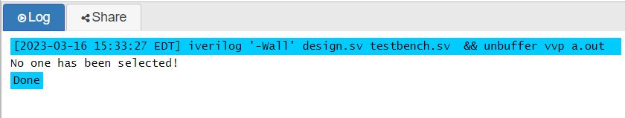

The above "if" Conditional statements output “No one has been selected” because the final display statement will always be executed as it is not contained within any of the "if" statement blocks. Yet, the third and fourth statements—"X! = Y" and "X==X"—are likewise true.

- if(a===yyyy): no matter what a’s value is, even x or z , if LHS exactly matches RHS, (a===yyyy) = 1.

Example:
module IfTest1();
reg [3:0] X;
reg [3:0] Y;
initial begin
X=4'b101x;
Y=4'b101z;
if(X===4'b101z)begin
$display("Statement 1 has been selected!");
end
if(X===Y)begin
$display("Statement 2 has been selected!");
end
if(X!==Y)begin
$display("Statement 3 has been selected!");
end
if(X===X)begin
$display("Statement 4 has been selected!");
end
$display("No one has been selected!");
end
endmodule
Ans: ?

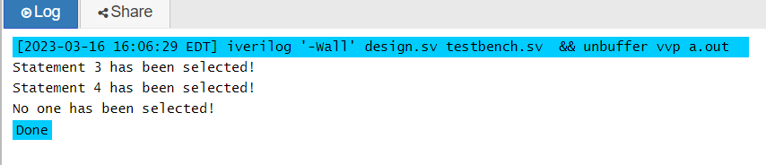

An equality comparison is used in the programme mentioned above. In addition to carrying out the same bit-wise comparison as ==, it also looks for any undefinable (x) or highly impedance (z) values. Because X and Y are not equal as a result of the high impedance value in Y's second bit, the third statement is true based on the results above. As X is equal to itself, statement 4 is likewise true and was chosen as the best option. Because the display statement is not contained within any of the "if" statement blocks, it will always be executed, making the last statement also true.

II. Continuous assignment with conditional operator

- If a has x or z in conditional operation, then a = x instead of other values in assignment.

Example:
module CondOp();
reg [3:0] X;
reg [3:0] Y;
wire Z;
assign Z=(X==Y)? 1'b1:1'b0;
//assign Z=(X===Y)? 1'b1:1'b0;
//assign Z=(X!==Y)? 1'b1:1'b0;
initial begin
X=4'b101x;
Y=4'b101z;
$monitor("Z's values: %d\n", Z);
end
endmodule

Ans: ?
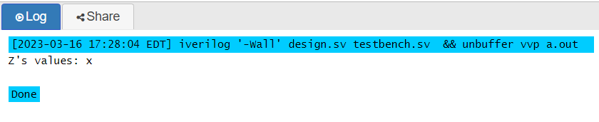

In the program above, X and Y values are compared. Z will be given the value of 1'b1 if they are equivalent and 1'b0 if they are not. The value of Z will be unknown since X = 4'b101x (where x is unknown) and Y = 4'b101z (where z is high impedance) (denoted by x). The case equality statement "X ===Y" and the equality operation "X! ===Y" will both have the identical effects.

- "case" conditional statement

- "case" is to match exactly for 1, 0 , x and z
Example:
module caseTest();
reg [3:0] X;
reg [3:0] Y;
initial begin
X=4'b101x;
Y=4'b101z;
case(X)
4'b1010: $display("Statement 1 has been selected!");
4'b101x: $display("Statement 2 has been selected!");
4'b101z: $display("Statement 3 has been selected!");
4'bxxxx: $display("Statement 4 has been selected!");
4'bzzzz: $display("Statement 5 has been selected!");
default: $display("Default has been selected!");
endcase
end
endmodule

Ans: ?
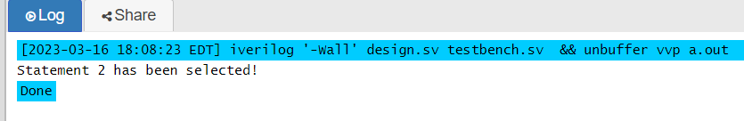

Statement 2 was selected since it matches the initialized value of X, which is 4’b101x.

    - "casex" conditional statement

- "casex" is to make x/z match 1, 0, x and z

Example:
module casexTest();
reg [3:0] X;
reg [3:0] Y;
initial begin
X=4'b101x;
Y=4'b101z;
casex(X)
4'b100z: $display("Statement 1 has been selected!");
4'b10xx: $display("Statement 2 has been selected!");
4'b11xz: $display("Statement 3 has been selected!");
4'bxxxx: $display("Statement 4 has been selected!");
4'bzzzz: $display("Statement 5 has been selected!");
default: $display("Default has been selected!");
endcase
end
Endmodule

Ans:

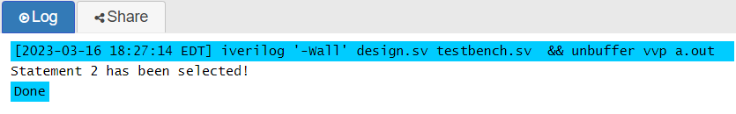

The second case, 4'b10xx, matches the value of X since its first two bits are 10 and its last two bits are don't care.

- Note: in this case, x looks like wildcard (?=1/0/x/z). So, we can write as follows:

Example:
module casex1();
reg [3:0] X;
reg [3:0] Y;
initial begin
X=4'b101x;
Y=4'b101z;
casex(Y)
4'b???1: $display("Statement 1 has been selected!");
4'b??1?: $display("Statement 2 has been selected!");
4'b?1??: $display("Statement 3 has been selected!");
4'b1???: $display("Statement 4 has been selected!");
default: $display("Default has been selected!");
endcase
end
endmodule
Ans: ?
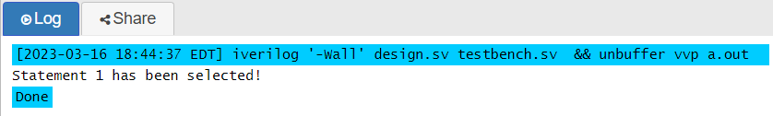

The Y input value 4'b101z will corresponds to the first sentence 4'b???1 since the question mark (?) in the first statement is a wildcard that can take the values 0 or 1. If Y had a value with a 1 in the least significant bit (LSB), such as 4'b0011 or 4'b1011, the casex statement would match that value and execute the first case statement, displaying "Statement 1 has been selected."

    - "casez" conditional statement

- "casez" is to make z match 1, 0 and z, but not x.

Example 1:
module casezTest();
reg [3:0] X;
initial begin
X=4'b1x00;
casez(X)
4'b100z: $display("Statement 1 has been selected!");
4'b10xx: $display("Statement 2 has been selected!");
4'b11xz: $display("Statement 3 has been selected!");
4'bxxxx: $display("Statement 4 has been selected!");
4'b0zzz: $display("Statement 5 has been selected!");
default: $display("Default has been selected!");
endcase
end
endmodule

Ans: ?
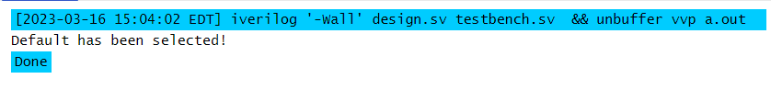

- In "casez" block, wildcard ? = 1/0/x/z.

With the initial value of X being "4'b1x00," the programme above uses a casez statement to choose an action. Casez, in contrast to the case statement, will accept the "don't care" value denoted by either "x" or "z". The programme will compare the initialized value of "X" to every pattern on the list. As none of the first five matches the initial "X" value "4'b1x00," the casez statement will default to the default case and output the message "Default has been selected."

Example 2:
module casez1();
reg [3:0] X;
initial begin
X=4'b1x00;
casez(X)
4'b???1: $display("Statement 1 has been selected!");
4'b??1?: $display("Statement 2 has been selected!");
4'b?1??: $display("Statement 3 has been selected!");
4'b1???: $display("Statement 4 has been selected!");
default: $display("Default has been selected!");
endcase
end
endmodule

Ans: ?

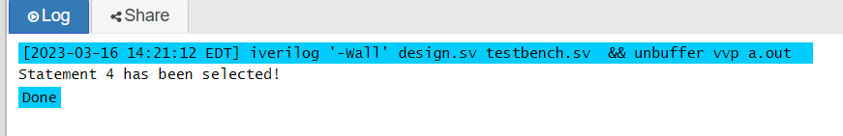

The programme above chose the statement "four" because, unlike the first three cases (4'b???1, 4'b??1, and 4'b?1??), the fourth case (4'b1???) wants to match any input with the first bit set to 1. This case will match because the first bit of X is 1, unlike the other three cases (4'b???1, 4'b??1, and 4'b?1??). As a result, "Statement 4 has been selected!" will be the output.

Notice that "casez" and "casex" should be avoided considering synthesis and other issues, if you can use simple "case" or "if" chains. If you can't, use "casez" instead of "casex".

    - Exercises
- Show the example program running results and explain why.

